Endocrine System Quiz Name: ________________ Mark: ______/15

Multiple Choice Section (4 marks)

1. The target organ for the hormone calcitonin is the
(a) parathyroid gland.
(b) adrenal gland.
(c) bones.
(d) liver.

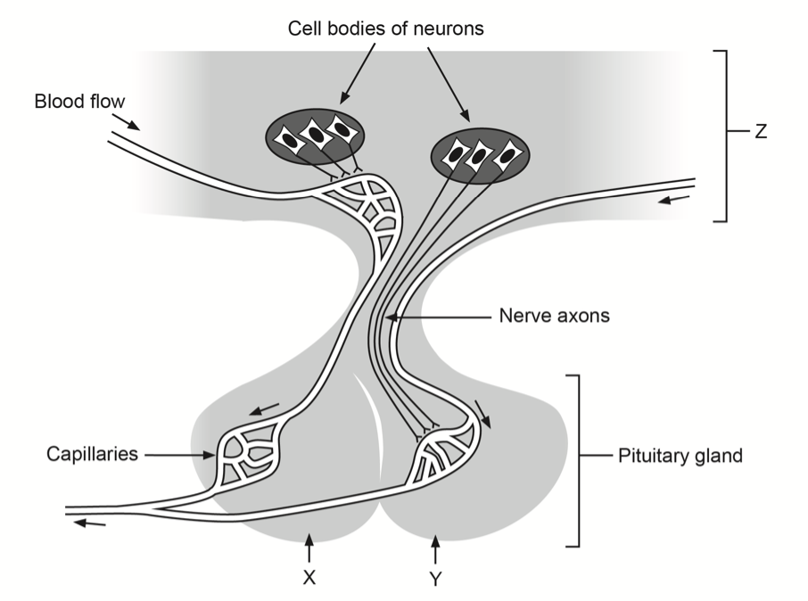
Questions 2-4 refer to the diagram below
2. Which part of the brain is shown as Z in the diagram?

(a) hypothalamus
(b) cerebrum
(c) brain stem
(d) medulla oblongata
- X and Y represent the two lobes of the pituitary gland. A target organ for hormones released from lobe Y is the
(a) thymus.
(b) thyroid gland.
(c) ovaries.
(d) uterus.

4. Which of the following correctly lists hormones only released from lobe X

(a) Follicle Stimulating Hormone, Adrenocorticotropic Hormone, Growth Hormone, Oxytocin
(b) Thyroid Stimulating Hormone, Prolactin, Luteinising Hormone, Thyroxin
(c) Antidiuretic Hormone, Luteinising Hormone, Thyroid-Stimulating Hormone, Growth Hormone
(d) Prolactin, Adrenocorticotropic Hormone, Thyroid-Stimulating Hormone, Luteinising Hormone

Short Answer Section (11 marks)

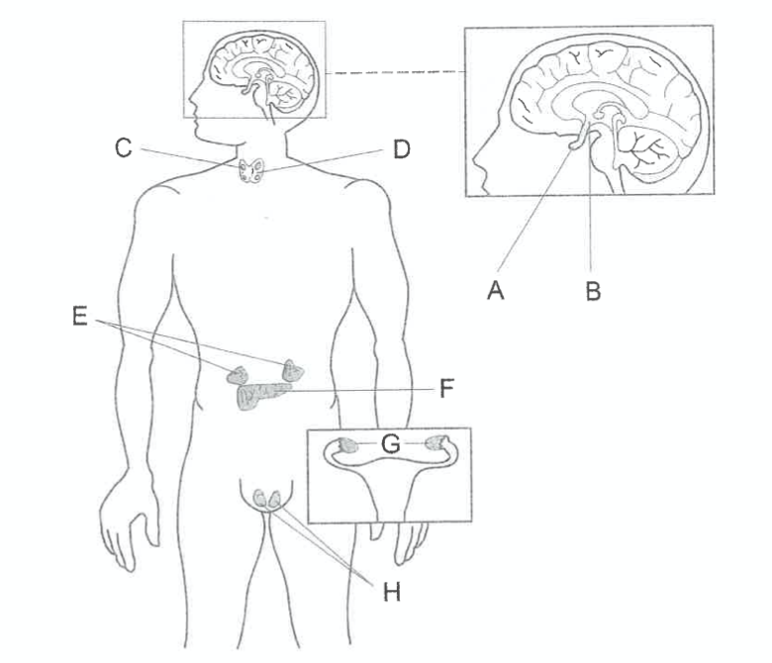
Question Five (5 marks)

- Identify the endocrine gland that

secretes the hormone aldosterone (1)
E/Adrenal glands/adrenal cortex

(ii) secretes the hormone that increases the metabolic rate in cells (1)
Thyroid/D

- Explain how structures A and B in the diagram on the previous page are involved in the production and release of antidiuretic hormone (ADH) (3)

Produced in B/Hypothalamus
Stored in A/posterior pituitary
Nerve impulse from B/hypothalamus triggers release

Question Six (3 marks)
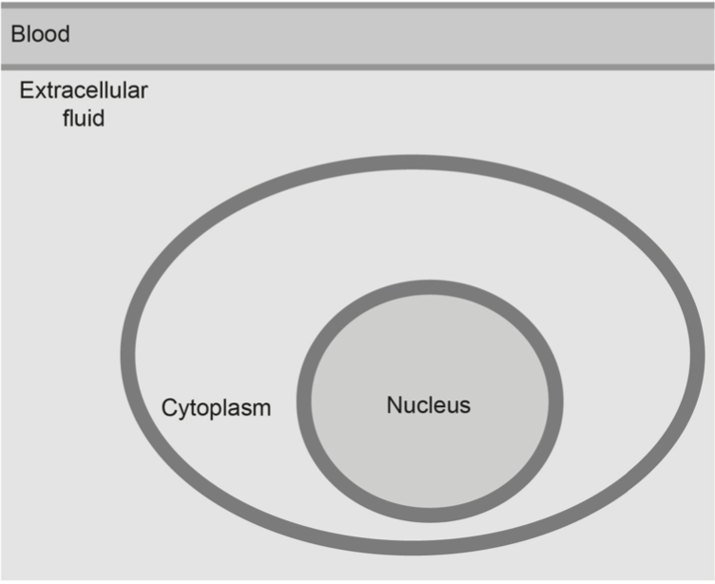
In the outline below, draw an annotated diagram of the mode of action of lipid-soluble hormone.

One mark for each:
Diffuses across the cell membrane
Hormone attaches to receptor in cytoplasm/hormone-receptor complex formed inside the cell (cytoplasm or nucleus)
Complex binds to DNA (inside nucleus) and activation of genes/transcription of mRNA/ protein synthesis occurs

Question Seven (3 marks)
Cushing’s syndrome, otherwise known as hypercortisolism, is a disease caused by prolonged exposure to excessive levels of cortisol. It is often cause by a tumour growing on the pituitary gland that alters its normal hormonal secretions. Patient’s with Cushing’s syndrome can have many different symptoms, including high blood pressure, weight gain, depression, memory dysfunction and bone and muscle weakness.

A patient with Cushing’s syndrome had a large pituitary tumour.

- (i) Which lobe of the pituitary gland would the tumour have affected? (1)

Anterior

(ii) Which pituitary hormone would have had its secretion altered by the tumour? (1)

ACTH - Adrenocorticotropic hormone

- Treatment for Cushing’s syndrome may require the removal of part of the pituitary gland or adrenal gland. Removing the affected endocrine gland may eliminate the high levels of cortisol; however, it can create other problems. Identify one such problem. (1)
Any one of:
Reduced amounts of other hormones produced by these structures/any specific example of a hormone that would be affected by removal of the adrenal glands or pituitary gland e.g. low TSH/LH/FSH/GH/PRL/MSH
Excessively low cortisol levels
Any specific problem caused by low cortisol E.g. fatigue/anxiety/depression

